**Digitalization**

To succeed in the future you need to seize the opportunities provided by digitalization right now. Digitalization promises lower costs, improved production quality, flexibility and efficiency. It brings a shorter response time to customer requests and market demands. Productivity and energy efficiency can increase thanks to an integrated power supply. Solutions for the digital enterprise are already here - regardless of the sector or company size.

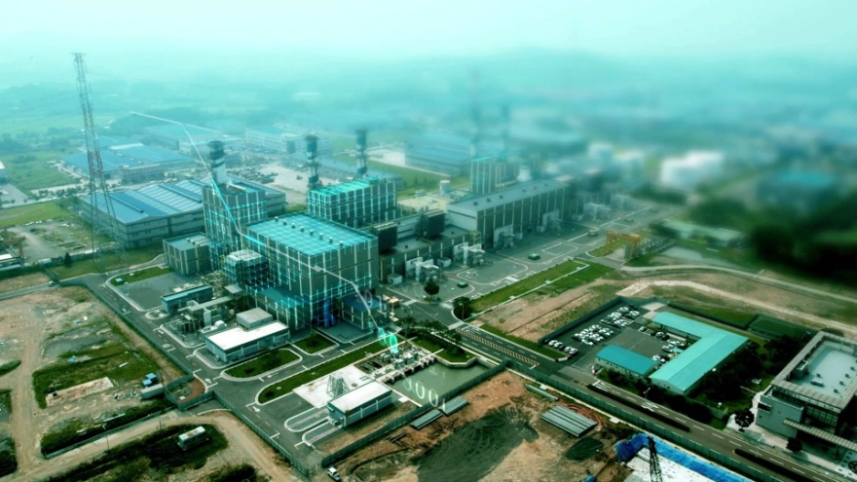

**Mindsphere**

MindSphere is the open, cloud-based IoT operating system from Siemens that lets you connect your machines and physical infrastructure to the digital world. It lets you harness big data from billions of intelligent devices, enabling you to uncover transformational insights across your entire business.

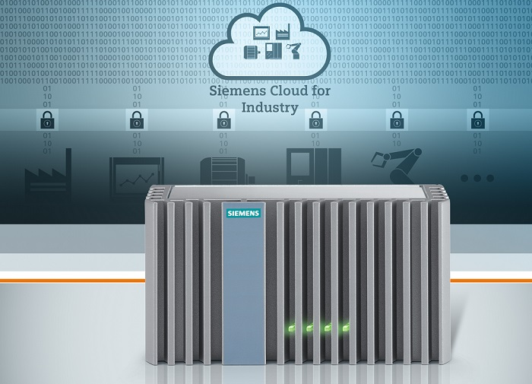

**Industrial Controls - SIRIUS**

Do you want to save time and effort? The SIRIUS modular system combines digital planning and a standard-compliant implementation for your requirement, regardless of the application or location. Comprehensive planning tools, consulting expertise, and tested product combinations will assist you in the transition from digital to actual control cabinet construction.

The SIRIUS modular system includes the portfolio for industrial control engineering for switching, protecting, monitoring, and starting motors and plants. This highly flexible modular system is quick to connect and communicate with other products and complies with all standards to ensure stress-free planning and construction of control cabinets.

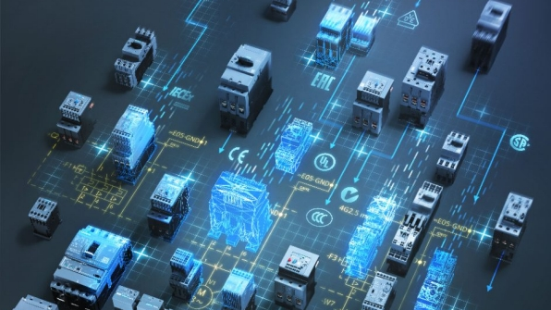

**Industrial Communication**

Industrial communications is essential for every industry. It facilitates the company-wide exchange of data across the entire value-added chain, from the field level to the management level, and provides for greater efficiency in all areas of the company. Industrial networks need to meet different requirements, depending on the industry.

In manufacturing, whether for controlling machines, monitoring production lines or coordinating entire production areas – we offer end-to-end, forward-looking and fail-safe communication solutions that cover all field devices while guaranteeing a high level of communication security.

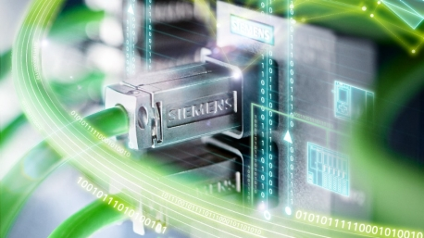

**Industrial Training**

At SITRAIN (**Si**emens **Tra**ining **In**stitute), we are committed to provide training to Siemens customers, channel partners, employees as well as students in educational institutes. This is a Siemens initiative to upgrade the skill development in the country and fill in the gap for such required skilled manpower.

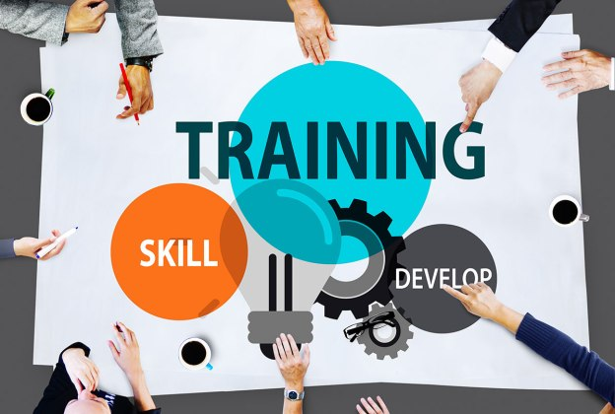

**Industry Software**

Industry Software from Siemens helps manufacturers become Digital Enterprises by enabling them to digitalize and integrate their entire industrial value chain through PLM solutions, Manufacturing Execution System (MES), Manufacturing Operations Management (MOM) solutions and TIA equipment into the industry-leading Siemens collaboration platform and single data backbone. The integration of PLM, MES/MOM and Automation is made possible with the comprehensive suite of Siemens Industry Software.



**Automation**

The demands on modern machines and plants are steadily growing in all industries. With the automation systems from Siemens, you can cover all requirements while benefiting from maximum efficiency, flexibility, and cost effectiveness. Its an ideal system for every tasks.

Total Integrated Automation (TIA), the industrial automation platform from Siemens, stands for all automation components working efficiently together. Its open system architecture covers the entire production process and is based on the consistent presence of shared characteristics: consistent data management, global standards, and uniform hardware and software interfaces.

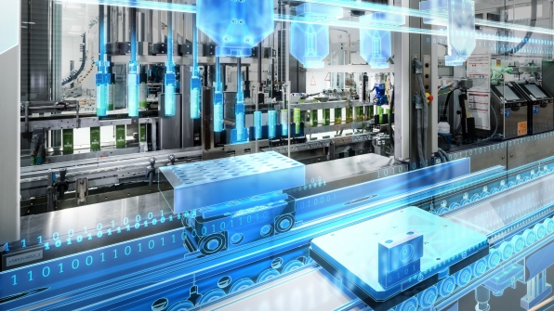

**Drives/Converters**

Siemens is providing a platform that satisfies the high requirements in the low-voltage, DC voltage and the medium-voltage ranges. It is based on a straightforward, standard engineering, is energy-efficient and so future-proof that it can keep up with every innovation step. Whatever direction you take, Siemens can offer you the optimum drive for it. The complete and integrated drive family addresses all of the performance levels and sets itself apart as a result of the highest degree of flexibility, functionality and efficiency.

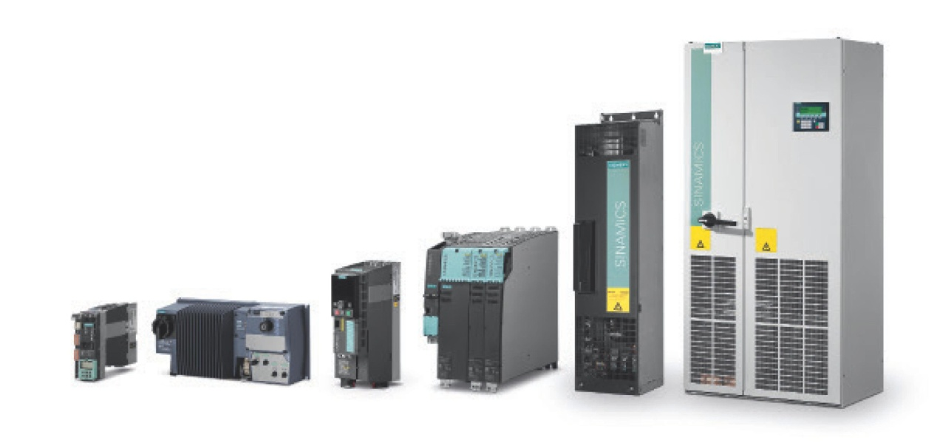

**Energy Efficient Motors**

Siemens enables users to boost competitiveness with higher energy savings, lower operating costs and reliability with its state of the art energy efficient motors. These motors with high dynamic performance, is a perfect fit for various sectors and applications due to its quality, efficiency and compactness. With over 150 years of global experience in motor manufacturing we strive to provide customized drive solutions for every application.

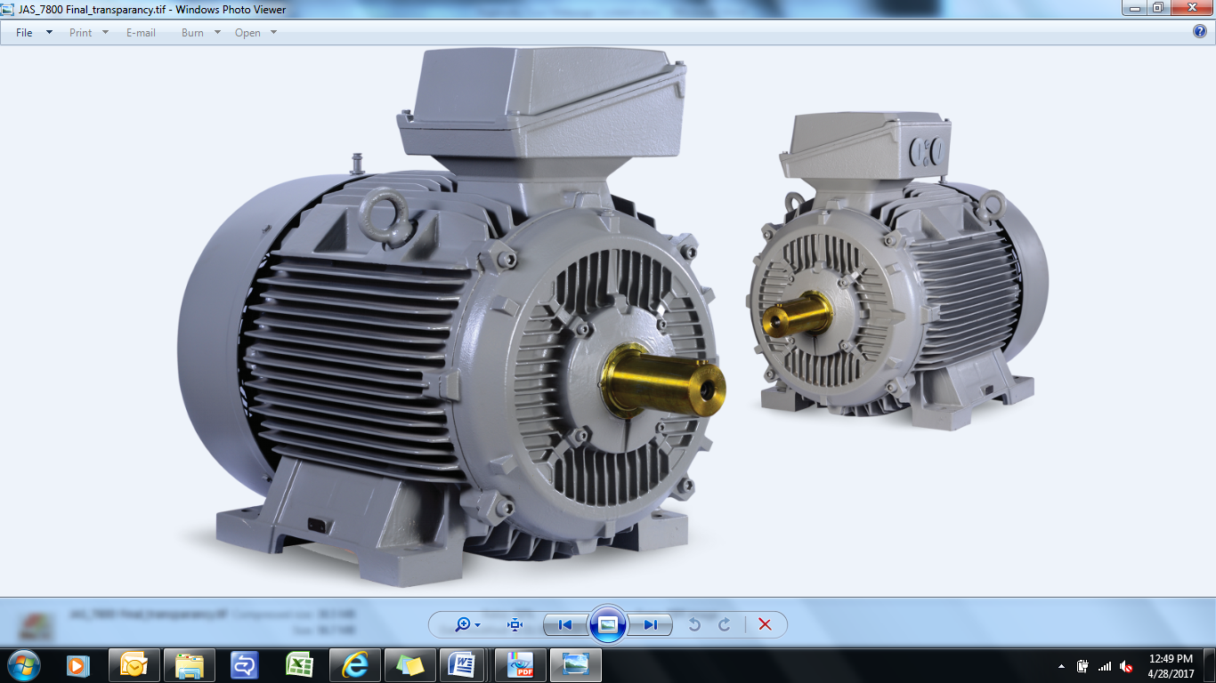

**Financial Service**

Siemens Financial Services (SFS) is a provider of business-to-business financial solutions. We support customer investments with equipment financing & leasing solutions as well with project and structured finance. Our specialized financial solutions, support productivity in industrial companies, drive energy efficiency and enable a wide variety of vendors to support sales and investment through flexible and tailored finance solutions. SMEs also benefit from our experience, sound risk assessment and customer service orientation.  Third-party customer’s benefit from our experience and sound risk assessment in Siemens’ markets: To expand our portfolio and to optimally position our products and services in the market, we serve customers outside the Company as well.



**Digital Enterprise**

The Digital Enterprise Suite enables manufacturing companies to streamline and digitalize their entire business process, seamlessly integrating suppliers into the mix. They can begin at any point of their value chain, from product design to service, and can extend digitalization gradually, depending on their current needs.  MindSphere (Siemens IoT solution) allows to analyze production assets and products as they perform and feed back the insights into the entire value chain for continuous optimization.

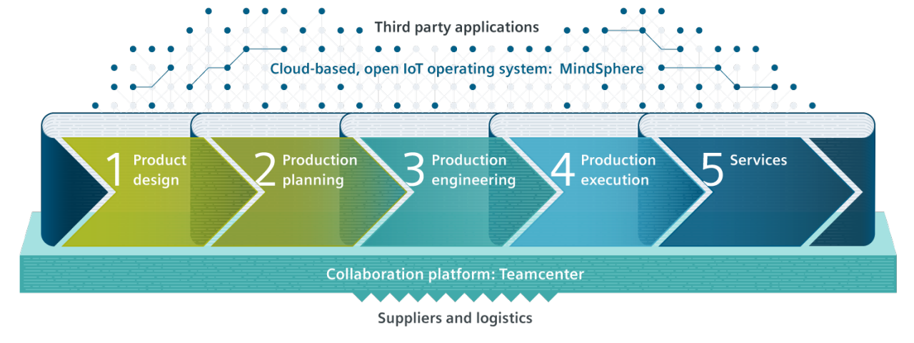

**Integrated Control Panels**

With the range of solutions from Siemens, you can easily optimize all aspects of control panel building which would save time and efforts. From preparation and configuration to design, construction, service, and support, we offer you a perfectly coordinated control panel solution. With expert know-how, tools and data for digitalization in engineering, and an aligned product and system portfolio, we ensure long-term success and greater competitiveness. That’s what the comprehensive approach of Integrated Control Panels stands for.

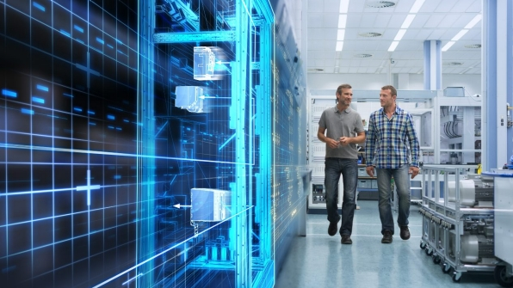

**Integrated solution for Machine Tools**

Siemens is the only supplier to offer end-to-end CAD/CAM-CNC process chain and solutions for networking machine tools and higher-level IT systems. Siemens India is supporting both machine manufacturers and operators on with the perfect blend between solutions like Virtual part production, OPC UA, SINUMERIK Operate, SINUMERIK Integrate and controllers like SINUMERIK PPU 161, SINUMERIK 828D Basic, SINUMERIK 828D Advanced and SINUMERIK 840Dsl to enhance productivity.

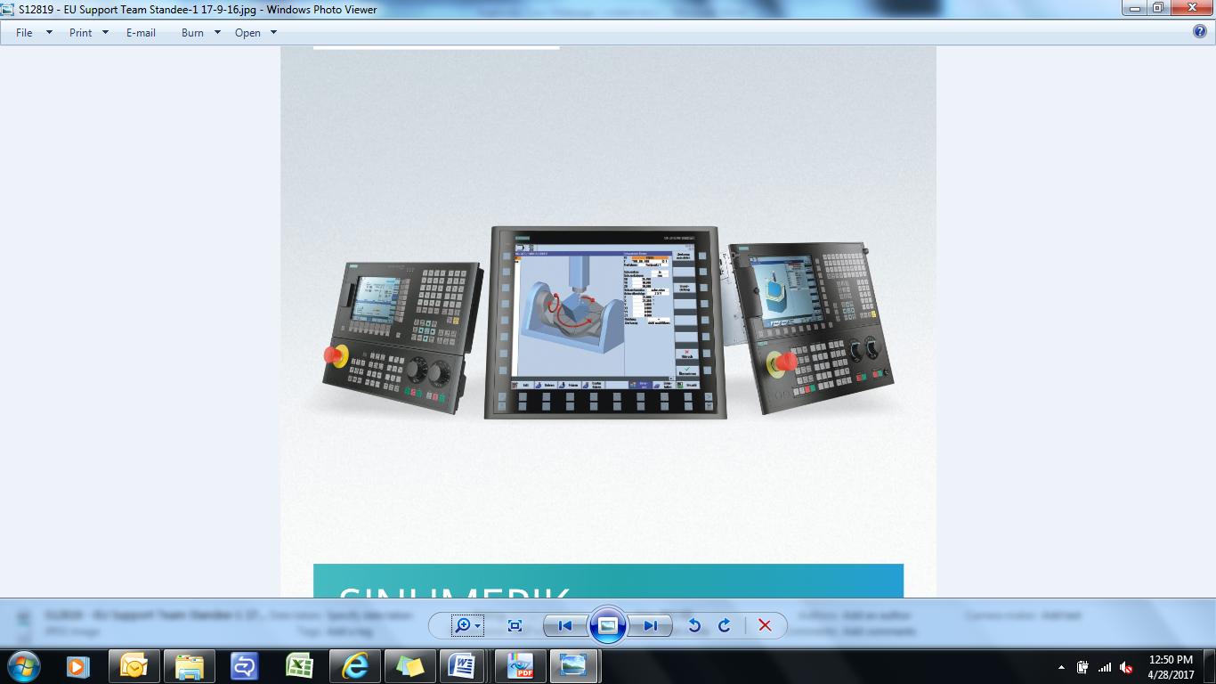

**Industry Services**

Industry Services from Siemens offer a vital contribution to increased competitiveness - throughout the entire lifecycle of your plant. Our global network of experts provides product-related services as well as specific consulting and services for the planning, engineering, operation, and modernization phases of industrial plants. We support you in increasing Productivity, Flexibility and Efficiency.

